**Abstract**

A prominent issue facing the world today is energy storage and the discharging/recharging of batteries. This is extremely prevalent in a variety of electronically powered devices and vehicles. These mobile devices, and state of the art vehicles use rechargeable Lithium Ion batteries. The problem, however, is that Lithium Ion batteries charge and discharge slowly, and are susceptible to battery corrosion. Super capacitors however, have a much faster charge and discharge rate, and have an extremely long lifetime. Yet they are not able to hold as much energy as lithium-ion batteries can because of the small surface area of their plates. We propose that replacing these batteries with graphene-silicene-germanene trilayer supercapacitors that have will be much more efficient and logical than using lithium ion batteries. The trilayer will be placed vertically to maximize the possible surface area, and therefore increase the super capacitor’s possible energy capacity.

**Beyond Lithium Ion Technologies: Supercapacitors with Graphene-Silicene-Germanene Trilayers for Increased Energy Capacity and Charge/Discharge Rates**

**Present Technology**

Everywhere we look, there seems to be some of sort of electronic gadget impacting our lives. Chances are that device runs on lithium-ion batteries. Currently, lithium-ion batteries are the widely utilised battery because of their high energy density, lightweight, seeming lithium abundance, and mass manufacturability.

Lithium-ion batteries store and release energy by moving electrons from one end of the battery to the other. The process of the electrons moving to the other side gives us the energy we use to power our devices. These two battery ends are known as electrodes. One is called the anode and the other one is called the cathode.The anode is usually made from carbon and the cathode is made from from a chemical compound known as a metal oxide. The liquid between the two electrodes is known as the electrolyte. In lithium-ion batteries, the electrolyte is a salt solution that contains lithium ions; hence the name lithium-ion. When you place the battery in a device, the positively charged lithium ions are attracted to the cathode, and move towards it across the electrolyte. Once it is bombarded with these ions, the cathode becomes more positively charged than the anode, and this attracts negatively charged electrons. As the electrons start moving toward the cathode, they go through our device and we use the energy of the electrons flowing toward the cathode to generate power. Electrons travel through an external circuit, and the ions flow through the electrolyte. This process is similar to that of a water wheel, but instead of water, we use electrons.

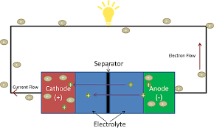

The lithium-ion battery’s versatility allows it to be used in different ways in various electronic devices and vehicles. For example, the powertrain on the Tesla Model S uses a 85 kWh battery pack that contains 7,104 lithium-ion battery [cells](https://en.wikipedia.org/wiki/18650) across 16 modules, and something like a traditional smartphone in your pocket uses 1 large lithium-ion battery holding 1715 mAh. However, lithium-ion batteries don’t come without their share of problems. The Samsung Galaxy Note 7 became quite infamous for its battery pack that spontaneously blew up in some people’s pockets. This can occur when the thin layer separating the two electrodes is damaged or breached by dendrites (long strands of accumulated lithium). When the two electrodes come into contact, overheating quickly occurs and can cause the combustion of the liquid electrolyte, leading to an explosion. While lithium-ion batteries are widely used today, they are not the safest or most efficient battery that can be used.

**History**

In 1800, Alessandro Volta invented the first battery which was used to develop the first electric telegraph towards the end of the industrial revolution. [Adam Heller](https://en.wikipedia.org/wiki/Adam_Heller) later proposed the lithium thionyl chloride battery in 1973, which is still used in implanted medical devices and in defense systems. It has a greater than a 20-year shelf life and a high energy density. The first commercial lithium-ion battery was released by [Sony](https://en.wikipedia.org/wiki/Sony) and [Asahi Kasei](https://en.wikipedia.org/wiki/Asahi_Kasei) in 1991. The supercapacitor however, was first conceptualized with in the 1950s, when General Electric engineers began experimenting with porous carbon electrodes, in the form of capacitors, based off of the design of [fuel cells](https://en.wikipedia.org/wiki/Fuel_cell) and [rechargeable batteries](https://en.wikipedia.org/wiki/Rechargeable_battery). The market for supercapacitors expanded slowly, until 1978 when Panasonic marketed its “Goldcaps” brand, selling supercapacitors commercially. This became a successful memory storage and backup device.

**Future Technology System**

Our idea for a future technology is to replace lithium-ion batteries with supercapacitors that use a graphene-silicene-germanene trilayer. Currently, graphene is being used in supercapacitors for the electrodes, but we will add in other 2D materials from group 14 of the periodic table- silicene and germanene. This will give our new trilayer supercapacitors a greater energy capacity and also a faster charge and discharge rate, making them much more efficient. In addition, the electrostatic reactions that take place within the supercapacitor drastically reduce the likeliness of a malfunction and result in many more charge/ discharge cycles.

Another component of the supercapacitor is the electrolyte. The function of the electrolyte is to provide an ionic conducting medium to separate the two electrodes. We know that the energy density of supercapacitors is limited by the use of aqueous-based gel electrolyte because of the reduced electrochemical window caused by water and that liquid-based electrolytes can be susceptible to leaking ergo damaging or interfering with other parts of the supercapacitor. In order to combat this we propose using an ionic liquid based gel polymer electrolyte composite with nanostructured SiO2. The composite would consist of polyvinylidene fluoride (PVDF) and imidazolium ionic liquid which both contain high ionic conductivity. When he three aforementioned compounds are tested as a composite, they have shown an increase in: capacitance, thermal stability, and the electrochemical window. The increased thermal stability and temperature range allows the supercapacitor to be used with superior performance and no ionic liquid leakage. Another benefit to this gel composite that is pliable is that it now can be used for a multitude of applications including: displays and screens, wearable tech, photovoltaics, and even medical devices. The last component of the supercapacitor is the separator. The purpose of the separator is to facilitate the transfer of ions between the two electrodes and the electrolyte, to act as an insulator between the electrode of opposite polarization, and to physically separate the two electrodes to prevent a short circuit from direct contact. A porous separator allows for low electrostatic resistance and ions to flow. We propose to use a resin-bonded cellulose separator, it is organic, inexpensive, and there’s minimal corrosion. Lastly, with all of this current and voltage bouncing around, there has to be a more than capable current collector to absorb and dispense any energy generated. The use of a heterogeneous current collector will provide maximal collection of energy. Overall we believe these new technological developments will result in supercapacitors with greater energy densities, varied applicability, a wide thermal range, and faster charge/discharge.

Silicene is a relatively newly discovered allotrope of silicon and is sought after for its potential to integrate with silicon based technologies and possible superconductivity. One proposed method of mass producing it is to anneal MoSi2 (Molybdenum Disilicide) at 650°C as opposed to placing monolayer amounts of silicon onto a heated growth substrate, commonly Ag(111). This method does work, however, silicene has also been known to degrade rather quickly, and needs to be kept in an airtight container to avoid contact with oxygen. Plus, allotropes formed on substrates tend to be difficult to remove. A similar approach will be taken with germanium, but due to a surface alloy formation when using Ag(111), Au(111) will be used instead. The results are similar to that of silicene growth on Ag(111), even retaining the hexagonal structure. Another reason the synthesization of silicene and germanene have not gained popularity is because neither allotrope forms a van der Waal layered structure, meaning they cannot hold a stable freestanding structure without being synthesized onto a substrate as an adlayer. Despite this, new two-dimensional materials are being pursued because theoretical tests show promising results similar to graphene. However, silicene and germanene are different than graphene in that they have band gap that naturally appear in the semiconductor range; whereas graphene has no band gap but when graphed in terms of energy (y) and momentum (x), form Dirac cones. The fact that graphene electrons have the same velocity and no inertia indicate they have near zero mass. This could also be the case with silicene and germanene, meaning their electrons could also travel at the speed of light at a near zero mass. If electrons were to travel at the speed of light, electricity would flow through a current much faster and therefore deliver electricity faster, a key advantage to supercapacitors over lithium-ion batteries.The band gap is important to understand because it categorizes materials into conductors, semi-conductors, or insulators based on certain eV thresholds that determine how the material will perform in terms of conductivity within the supercapacitor. After isolating a few nanometers of each allotrope, the next step is to form the trilayer. The electrodes go on the outside, followed by the separators, and then the electrolyte in the middle. Each of the three components should be the full length of the supercapacitor. There should be 10 angstroms of each allotrope in the following order: graphene on top, silicene next, and germanene last. Then take 5 angstroms thick of your separator and 1 angstrom of the electrolyte. As far as stacking is concerned, an ABA, or Bernal, stacking method is shown to be the most stable formation, possibly because of the direct alignment of the first and third layers right on top of each other. If we were to use an ABC, or rhombohedral, stacking method, the entire trilayer would become insulating as opposed to conducting; the reason for this is unknown, but we believe it’s because of the minimized amount of aligned atoms in their covalent bonds. In order to maximize the amount of components, all of the components must be tightly spiraled. Our supercapacitors will also include heterogeneous current collectors. This way the heat generation becomes negligible when the capacitor is subjected to mechanical abuse.

**Breakthroughs**

Some necessary breakthroughs that will need to be made are mass production of silicene, graphene, and germanene. Each of these compounds are not found in nature and need special processes to extract them in large quantities. The development of a simple, scalable and reproducible technique for the synthesis of two-dimensional nanosheets of these materials is of paramount importance in the field of our future supercapacitors. After the mass development of these three allotropes, the next step is to fuse the three layers into a functioning trilayer. Maybe slapping them on top of each other would work, but there’s likely a more effective solution to increase capacitance by increasing the surface area. Heating soybean oil to 800°C and then dissolving the carbon atoms through a polycrystalline nickel substrate has proven effective in producing lots of graphene but not in the desired single-atom thick configuration.

One of the biggest reasons that supercapacitors do not rival batteries right now is because of their poor energy density. Supercapacitors cannot store as much energy as lithium-ion batteries do. Once we implant the new trilayers into the supercapacitors, the energy density of these capacitors will increase greatly because they will provide a greater surface area which is known to increase capacitance. This will make supercapacitors highly competitive with lithium-ion batteries.

**Design Process**

One feature we proposed in our project was a more efficient current collector. This in itself is not bad, or inefficient, but it certainly could be improved. Instead, we decided to use heterogeneous current collectors. These heterogeneous current collectors are heat resistant, and will not overheat due to mechanical abuse.

Graphene has been the subject of much controversy and hype over the years, because of its chemical properties, specifically pertaining to electrical and thermal conductivity. And while it would have a high performing supercapacitor on its own, we realized having several elements from group 14 allowed to us have single layer allotropes with similar properties. Each allotrope has a different atomic radius, ionization energy, and electronegativity because of the greater number of energy shells as you move down the group. This causes greater repulsion between the electrons, and makes it easier for the electrons to be removed from their atom . Using a tri layer of different allotropes from similar elements allows electrons to avoid the disadvantages of each allotrope for more than one layer.

The main disadvantage to graphene, from the perspective of its properties, is its lack of a band gap. Although it is a great conductor of electricity, it does not have the properties of a semiconductor, such as silicene. A semiconductor has a band gap between that of an insulator and a conductor. The reason silicon is used as a semiconductor is its ability to regulate the flow of electrons in transistors.

One component we were surprised to learn had a significant impact on the supercapacitor overall was the stacking method. The stacking method is essentially the order in which the single layer allotropes are stacked on top of each other. We considered two common solutions: ABA, or Bernal, stacking and ABC, or rhombohedral, stacking. These two methods differ in their alignment of atoms in a minimum of three single layer allotropes. In the ABA method, layers A and A are fully aligned and layer B is shifted over one atom and every other atom is aligned with the A layers. By contrast the ABC method stacks by shifting each successive layer over one atom, the same as the A to B alignment. One study though, made our decision to choose the ABA method. It demonstrated that the ABA method acted like a conductor, whereas the ABC method acted like an insulator. We believe the former acts like a conductor because of the greater amount of aligned atoms, and the latter is like an insulator because of the lack of atom alignment. Insulation can be helpful to minimize the effects of potential overvoltage and to separate the two electrodes and electrolytes. However, two of the three single layer allotropes we propose have semiconductor properties, and are capable of regulating current flow on their own.

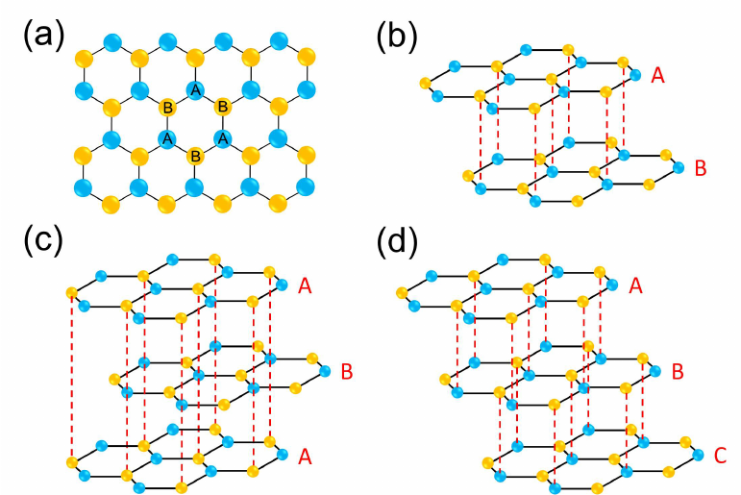

**Consequences**

Once these new, and more efficient supercapacitors are developed, there will be a vast majority of positive consequences, but also some negative ones. This technology will be a disruptive technology, and many other companies, such as those who make lithium-ion batteries will lose a large portion of their business sales. However, this could be the window into a new supercapacitor market. This could have an adverse effect on the economy because it will take a long time for companies to fully adopt the new supercapacitors. This is not the end of lithium-ion batteries, because they can be used to compliment supercapacitors in certain niche applications, like those being used today.